**Experiment 01 Name:** Verification of Ohm’s Law

**Objective:**

1. We have to find the resistance of a resistor from its color code.
2. We have to measure voltage, current and resistance values using a digital Multimeter.
3. We have to verify the validity of Ohm’s Law.
4. We have to test the voltage divider rule in a series circuit.

**List of Equipment:**

1. Bread board
2. DC power source
3. Resistors (3.3 KΩ, 5.6 KΩ)
4. Digital Multimeter (DMM)
5. Connecting Wire

**Theory:**

Ohm’s law states that the electrical current flowing through any conductor is directly proportional to the potential difference between its ends, assuming the physical conditions of the conductor do not change. In other words, the ratio of potential difference between any two points of a conductor to the current flowing between them is constant, provided the physical conditions do not change. Mathematically, Ohm’s law can be expressed as, I∝V, which with the constant of proportionality, the resistance R in the above equation, I = $\frac{V}{R}$ or, V=IR.

Basically, in this experiment, we are going to verify the Ohm’s Law. For that we need two resisters, one is 3.3 KΩ and the other one is 5.6 KΩ. When a resistor is kept at a constant temperature, its resistance will remain unchanged. We can confirm this experimentally by connecting a resistor to a power supply and measuring the current in the resistor as the supply voltage is increased. For that we also need four most important equipments. They are:

**Bread board:** A breadboard is a solderless device for temporary prototype with electronics and test circuit designs. The main section within the center of the breadboard is the prototyping area. This area consists of holes that are connected together in 5-hole rows. There is a channel between the two sets of rows for placing chips that have pins on both sides which prevents pins from being connected together. There are also power busses (usually one or two) along the sides of the breadboard for running power and ground around the entire board.

**Resistors:** Resistors values are often indicated with color codes. Resistor color coding uses colored bands to quickly identify a resistors resistive value and its percentage of tolerance with the physical size of the resistor indicating its wattage rating. Generally, the resistance value, tolerance, and wattage rating are printed on the body of a resistor as numbers or letters when the resistors body is big enough to read the print, such as large power resistors. A resistor-colored Orange-Orange-Red-Gold would be 3.3 kΩ with a tolerance of +/- 5% and a resistor-colored Green-Blue-Red-Gold would be 3.3 kΩ with a tolerance of +/- 5%.

**Digital Multimeter:** A digital multimeter is also known as multitester or volt-ohm-milliammeter is mainly an electronic measuring instrument that combines various measurement functions in a single unit. A digital multimeter comprises a numeric display in addition to a graphical bar that represents the measuring value. It consists of a selector switch to select the electrical characteristics to measure, an internal circuit, an analog to digital converter and an LCD display to take the readings. There is a selection knob which allows the user to set the multimeter to read different things such as milliampere (mA) of current, voltage (V) and resistance (Ω). Two probes are plugged into two of the ports on the front of the unit. COM stands for common and is almost always connected to Ground of a circuit. The COM probe is conventionally black but there is no difference between the red probe and black probe other than color. 10A is the special port used when measuring large currents. mAVΩ is the port that the red probe is conventionally plugged in to. This port allows the measurement of current up to 200mA, voltage and resistance. The probes have a banana type connector on the end that plugs into the multimeter. Any probe with a banana plug will work with this meter. This allows for different types of probes to be used.

**DC Power Supply:** A DC power supply, also known as a bench power supply, is a type of power supply that gives direct current voltage to power a device. It can use AC, DC, battery, or ultralow voltage as inputs. It also have four basic outputs: constant voltage, constant current, voltage limit, and current limit. DC power supplies will usually have multiple channels. In our labs the power supplies have two channels and we noticed that one is labelled “FIXED”. Because one can produce an output that ranges anywhere, while the FIXED channel can only produce an output of 5V.

**Questions and Answers:**

**Experiment 1:**

1. State Ohm’s law.

Answer: Ohm’s law: Current through a conductor between two points is directly proportional to the voltage across the two points.

Mathematically, Ohm’s law can be expressed as, I∝V

Which with the constant of proportionality, the resistance R in the above equation, I = or, V=IR

2. Plot V vs. I graph for each resistor value in same graph.

Answer: We had already measured the current flowing through the resistor by the Digital Multimeter in Laboratory and filled Table 2 with those values. Now we get the values from Table 2 and plotting the values on the graph.

|  |  |  |
| --- | --- | --- |
| V(IR) | $I_{3.3}$ (mA) | $I_{5.6}$ (mA) |
| 2 | 0.62 | 0.38 |
| 4 | 1.24 | 0.72 |
| 6 | 1.86 | 1.08 |
| 8 | 2.48 | 1.45 |
| 10 | 3.09 | 1.81 |

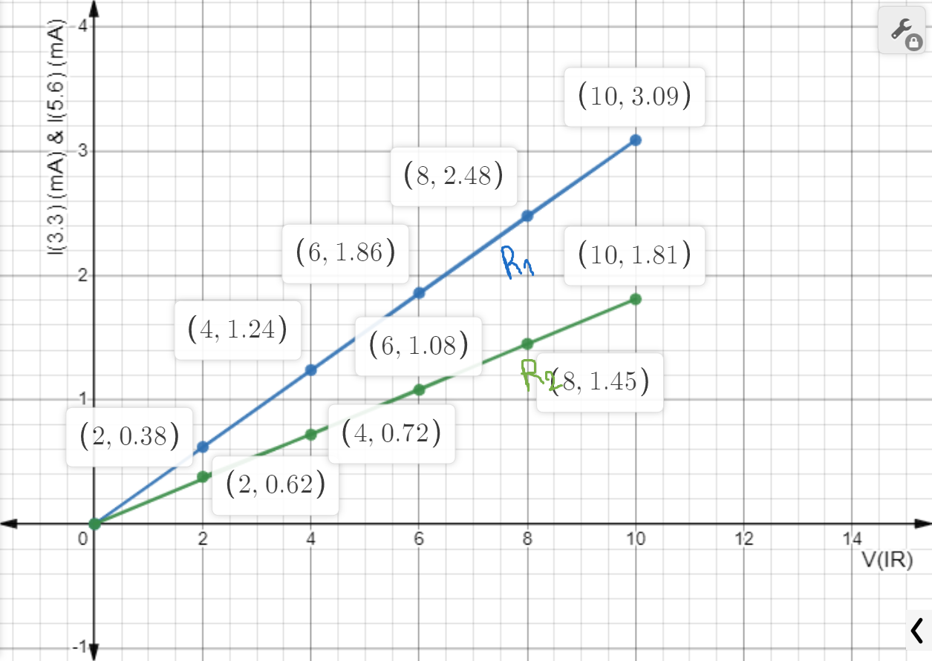

3. Does your experimental circuit follow Ohm’s law? Explain how you figured it out.

Answer: Given,

Voltage, V = (2V, 4V, 6V, 8V, 10V)

Resistance, R = (3.3KΩ, 5.6KΩ)

We know, V = IR

Or, I = $\frac{V}{R}$

|  |  |  |
| --- | --- | --- |
| Voltage(V) | $I_{3.3}$ = $\frac{V}{R_{1}}$ (mA) | $I_{5.6}$ = $\frac{V}{R_{2}}$ (mA) |
| 2 | 0.61 | 0.36 |
| 4 | 1.21 | 0.71 |
| 6 | 1.81 | 1.07 |
| 8 | 2.42 | 1.42 |
| 10 | 3.03 | 1.78 |

Yes, our experimental circuit follow Ohm’s law. Ohm’s law states that the electrical current flowing through any conductor is directly proportional to the potential difference voltage between its ends, assuming the physical conditions of the conductor do not change. So, V=IR or, I = $\frac{V}{R}$. Therefore, if we use the Ohm’s law with the given resistor and voltage values, we can get our theorical data. Here we can see the theorical data and our experimental data[from(2)] are almost same. For that reason, we can figure out that our experimental circuit follow Ohm’s law.

4. Calculate the resistance of each circuit using the slope of your V vs. I graphs. Compare these R values from the graph to the measured R values using DMM. Find the percent difference.

Answer: We get, Resistance, R = $\frac{V}{I}$

|  |  |  |  |  |  |  |  |  |  |
| --- | --- | --- | --- | --- | --- | --- | --- | --- | --- |
| Experimental Data (Using DMM) | | | | | Theoretical Data (Using Ohm’s Law) | | | | |
| v(V) | I(mA) | I`(mA) | R(KΩ) | R`(KΩ) | v(V) | I(mA) | I`(mA) | R(KΩ) | R`(KΩ) |
| 2.01 | 0.62 | 0.38 | 3.2 | 5.5 | 2 | 0.61 | 0.36 | 3.3 | 5.6 |
| 4.02 | 1.24 | 0.72 | 3.2 | 5.5 | 4 | 1.21 | 0.71 | 3.3 | 5.6 |
| 6.03 | 1.86 | 1.08 | 3.2 | 5.5 | 6 | 1.81 | 1.07 | 3.3 | 5.6 |
| 8.04 | 2.48 | 1.45 | 3.2 | 5.5 | 8 | 2.42 | 1.42 | 3.3 | 5.6 |
| 10.02 | 3.09 | 1.81 | 3.2 | 5.5 | 10 | 3.03 | 1.78 | 3.3 | 5.6 |
|  |  |  | $$∑R=16$$ | $$∑R`=27.5$$ |  |  |  | $$∑R=16.5$$ | $$∑R`=28$$ |

Experimental Data (Using DMM) mean: $M_{R}$ = $\frac{∑R}{N}$ = $\frac{16}{5}$ = 3.2

$M_{R`}$ = $\frac{∑R`}{N}$ = $\frac{27.5}{5}$ = 5.5

Theoretical Data (Using Ohm’s Law) mean: ${M`}_{R}$ = $\frac{∑R}{N}$ = $\frac{16.5}{5}$ = 3.3

${M`}_{R`}$ = $\frac{∑R`}{N}$ = $\frac{28}{5}$ = 5.6

The percent difference or Error for the first resistance

= $\frac{|M_{R} - {M`}_{R} |}{{M`}_{R} }$ X 100% = $\frac{|3.2- {3.3}_{|}}{3.3}$ X 100% = 3.03%

The percent difference or Error for the second resistance

= $\frac{|M_{R`} - {M`}_{R`} |}{{M`}_{R`} }$ X 100% = $\frac{|5.5- {5.6}_{|}}{5.6}$ X 100% = 1.79%

**Experiment 02 Name:** Series Circuit

**Objective:**

1. We have to learn how to connect a series circuit on a breadboard.
2. We have to validate the voltage divider rules.
3. We have to verify Kirchhoff’s voltage law.

**List of Equipment:**

1. Bread board
2. DC power source
3. Resistors (3.3 KΩ, 4.7 KΩ, 5.6 KΩ)
4. Digital Multimeter (DMM)
5. Connecting Wire

**Theory:**

**Experiment 2:**

1. State the voltage division rule.

Answer: Voltage Division Rule:The total voltage applied across a series connection of multiple resistors is divided among the resistors in proportional to their resistance. The voltage division rule can be expressed as = .

2. State the Kirchhoff’s voltage law (KVL).

Answer: Kirchhoff’s voltage law (KVL): The voltage around a closed path algebraically sum to zero. In other words, the sum of voltage rise equals the sum of voltage drop.

The equation is: = 0

3. Showing all steps, calculate the theoretical values in Table 2. Compare theoretical values to your experimental values and explain whether your circuit follows KVL or not.

Answer: Experimental Data:

Total Resistance, $R_{T}$ = $R_{1}$ + $R_{2}$ + $R_{3}$ = (3.195 + 4.65 + 5.54) KΩ = 13.385 KΩ

Power Source, $V_{S}$ = 15.05 V

$V_{R1}$ = $\frac{15.05 X 3.195}{13.385}$ V = 3.591 V

$V_{R2}$ = $\frac{15.05 X 4.65}{13.385}$ V = 5.21 V

$V_{R3}$ = $\frac{15.05 X 5.54}{13.385}$ V = 6.21 V

Theoretical Data:

Total Resistance, ${R`}_{T}$ = ${R`}_{1}$ + ${R`}_{2}$ + ${R`}_{3}$ = (3.3 + 4.7 + 5.6) KΩ = 13.6 KΩ

Power Source, ${V`}_{S}$ = 15 V

${V`}_{R`1}$ = $\frac{15 X 3.3}{13.6}$ V = 3.64 V

${V`}_{R`2}$ = $\frac{15 X 4.7}{13.6}$ V = 5.18 V

${V`}_{R`3}$ = $\frac{15 X 5.6}{13.6}$ V = 6.18 V

Compare or Error:

$V_{1}$ = $\frac{|V_{R1}- {V`}_{R`1|}}{{V`}_{R`1}}$ X 100% = $\frac{|3.591- {3.64}_{|}}{3.64}$ X 100% = 1.35%

$V_{2}$ = $\frac{|V_{R2}- {V`}_{R`2|}}{{V`}_{R`2}}$ X 100% = $\frac{|5.21- 5.18|}{5.18}$ X 100% = 0.58%

$V_{3}$ = $\frac{|V_{R3}- {V`}_{R`3|}}{{V`}_{R`3}}$ X 100% = $\frac{|6.21- 6.18|}{6.18}$ X 100% = 0.49%

For Experimental Data:

Voltage Rise = 15.05 V $≈$ 15 V

Voltage Drop = ($V_{R1}+V_{R2}+V_{R3}$) = (3.591+5.21+6.21) V = 15.01 V $≈$ 15 V

For Theoretical Data:

Voltage Rise = 15 V

Voltage Drop = (${V`}_{R`1}+{V`}_{R`2}+{V`}_{R`3}$) = (3.6+5.18+6.18) V = 15 V

Therefore, voltage rise = voltage drop which follows KVL.

4. Showing all the calculations, theoretically calculate Vab. Compare with the experimental value and verify the voltage division rule at the terminal a-b.

Answer: Experimental Data: $V_{ab}$ = 11.46 V

Theoretical Data:

${V`}_{ab}$ = ${V`}_{s}$- ${V`}_{a}$ = (15 – 3.64) V = 11.36 V

Compare or Error = $\frac{|V_{ab}- {V`}_{ab|}}{{V`}_{ab}}$ X 100% = $\frac{|11.46- {11.36}_{|}}{11.36}$ X 100% = 0.88%

As the result is almost same, we can say that the voltage division rule at the terminal a-b is verified.

5. Showing all the steps, calculate Req. Compare with the experimental value.

Answer: Experimental Data: $R_{eq}$ = 13.41 KΩ

Theoretical Data: ${R`}_{eq}$ = ${R`}_{1}$ + ${R`}_{2}$ + ${R`}_{3}$ = (3.3 + 4.7 + 5.6) KΩ = 13.6 KΩ

Compare or Error = $\frac{|R_{eq} - {R`}_{eq} |}{{R`}_{eq} }$ X 100% = $\frac{|13.41- {13.6}_{|}}{13.6}$ X 100% = 1.397%